A project on
Keyword Extraction
Submitted by
Team members
AP23110010012 | Ganta.Rajesh
AP23110011086 | Chekuri.Harshitha
AP23110011210 | Paladugu.Sruthi
AP23110010952 | Damaracharla.Hitheeswar
AP23110010848 | GajulaGayathri

Bachelor of Technology In Computer Science and Engineering
School of Engineering and Sciences


Under the guidance of
MR.Shiva Charan
[November, 2025]
SRM University, AP, Neerukonda, Mangalagiri, Guntur.
Andhra Pradesh – 522 240

Department of Computer Science and Engineering
SRM University, AP

CERTIFICATE

This is to certify that the Project report entitled “Keyword Extraction ” is being submitted by students of Department of Computer Science and Engineering, SRM University, AP, in partial fulfillment of the requirement for GenAI B. Tech (CSE), Semester V. carried out by him during the academic year 2025-2026.

MR.Shiva Charan

Project Description
Keyword Extraction is an advanced Natural Language Processing (NLP) project designed to automatically identify the most important words and phrases from any given text. These keywords reflect the core ideas, concepts, and topics discussed in the content. They help in summarization, information retrieval, classification, search optimization, and topic modeling.
This project uses GenAI-supported techniques along with linguistic features to extract keywords with high accuracy. The system combines:
- Named Entity Recognition (NER) using spaCy
- Noun Chunk Extraction using dependency parsing
- TF-IDF Based Keyword Scoring
- Text Cleaning and Normalization
- Confidence Scoring and Filtering
- Keyword Ranking and Quality Validation
Using multiple extraction techniques together improves the overall accuracy, coverage, and reliability of extracted keywords. The system is further integrated into a Streamlit Web Application for a user-friendly interface where users can paste any text and instantly get the most meaningful keywords.
The tool is scalable, fast, and suitable for real-time keyword extraction from news articles, research papers, blogs, documentation, and social media content.

Project Scenarios

Scenario 1: News Article Analysis
A journalist needs to quickly identify important topics from a long news article. By pasting the article into the Keyword Extraction system, the tool extracts essential phrases such as names of people, locations, events, and organizations. This helps in generating metadata, summaries, and searchable tags for archiving or publication.

Scenario 2: Research Paper Keyword Extraction
Students and researchers often deal with large academic papers. The system processes research abstracts or full papers to extract technical terms, scientific concepts, and domain-specific keywords. This helps in literature review, indexing, and preparing presentations.

Scenario 3: Social Media Trend Detection
Marketing teams use keyword extraction to detect trending topics from social media posts. When hundreds of comments or tweets are copied into the extractor, the system identifies central topics, brands, and public sentiments. This improves campaign monitoring and brand analysis.

Scenario 4: Documentation and Help-Center Optimization
Technical writers extract keywords from software documentation and manuals. These keywords help build a search-friendly documentation portal and improve content discoverability.

Prerequisites
To complete this project, you need the following:

Software Requirements
- Python 3.7+
- Streamlit
- SpaCy
- NLTK
- Scikit-learn
- NumPy / Pandas
- Pip package manager
- Web browser (Chrome/Edge)

Python Libraries to Install
- spaCy model
- NLTK datasets
- Streamlit
- Scikit-learn
- Pandas
- NumPy
These libraries support text preprocessing, linguistic analysis, ML operations, and UI rendering.

Prior Knowledge
To fully understand this project, you should have knowledge of the following:

NLP Concepts
- Tokenization
- Stopwords
- Lemmatization
- Part-of-Speech tagging
- Named Entity Recognition
- Chunking
- N-grams

Machine Learning Concepts
- TF-IDF
- Vectorization
- Feature extraction
- Confidence scoring

Web Framework Basics
- Streamlit basics
- Frontend-to-backend communication

Project Flow
The flow of the Keyword Extraction system is:
- User enters text in the interface
- System preprocesses text (cleaning, normalization)
- NLP pipeline processes text using spaCy
- Model extracts keywords through NER, chunks, TF-IDF
- Scores are combined and filtered
- Top keywords are displayed along with confidence scores
- Keywords are exported through JSON/CSV options
- Text statistics are analyzed in the Analyze tab

Project Activities
This project is divided into multiple milestones to ensure a structured workflow. Each milestone contains several activities similar to the format in the Anemia Detection sample.

Milestone 1: Data Collection & Preparation
Keyword Extraction systems typically work on text-based datasets. In this project, the system accepts user-provided text, so the focus is on preparing the text for keyword extraction.

Activity 1.1: Collecting Text Data
Since this is a keyword extraction system, the dataset is not fixed. The user provides:
- Articles
- News content
- Research abstracts
- Social media posts
- Technical documentation
Each input is treated as a fresh dataset for the model.
Examples of suitable text sources:
- News websites
- Online journals
- Blogs
- PDF content pasted into the app
- Academic research papers
- Long-form social media posts

Activity 1.2: Importing the Required Libraries
The system uses multiple Python libraries for text processing and NLP. These include:
- spaCy – for Named Entity Recognition and linguistic processing
- NLTK – for tokenization and stopword filtering
- scikit-learn – for TF-IDF keyword scoring
- NumPy and Pandas – for data handling
- Regular expressions – for text cleaning
- Streamlit – for user interface
These libraries work together to analyze and extract meaningful keywords from the input text.

Activity 1.3: Reading the Text Input
Instead of loading a CSV dataset, the system reads user-entered text from the Streamlit interface.
The text is then passed to the preprocessing module, where it undergoes cleaning, validation, and normalization.

Activity 1.4: Text Preparation
Before keyword extraction, the input text must be processed to remove unnecessary elements.
Text preparation involves:

1. Removing unwanted elements
- Links (URLs)
- Email addresses
- Extra whitespace
- Special characters
- Unexpected punctuation

2. Normalizing the text
- Lowercasing
- Handling sentence boundaries
- Standardizing spacing

3. Tokenization
- Splitting text into words
- Splitting text into sentences
Tokenization helps in linguistic parsing and further analysis.

Activity 1.5: Handling Missing or Invalid Inputs
The system validates user input:
- Text must not be empty
- Minimum length must be met (e.g., 10 characters)
- Text cannot exceed system limits
This prevents processing errors and improves reliability.

Activity 1.6: Cleaning Duplicates in Text
Although the text is usually unique, sometimes user-provided text contains repeated lines or repetitive patterns.
The cleaning pipeline removes repetitive whitespace and repeated non-essential content.

Activity 1.7: Checking Text Quality
A quick text analysis is performed:
- How many words?
- How many unique words?
- Repetitive patterns?
- Presence of only stopwords?
This analysis ensures the text is meaningful enough for keyword extraction.

Milestone 2: Exploratory Text Analysis (ETA)
Exploratory Text Analysis helps understand the structure and characteristics of the input text.
Just like EDA in datasets, ETA examines all aspects of text content.

Activity 2.1: Descriptive Text Statistics
The system computes various statistics:
- Character Count
- Word Count
- Sentence Count
- Unique Words
- Average Word Length
- Vocabulary Richness
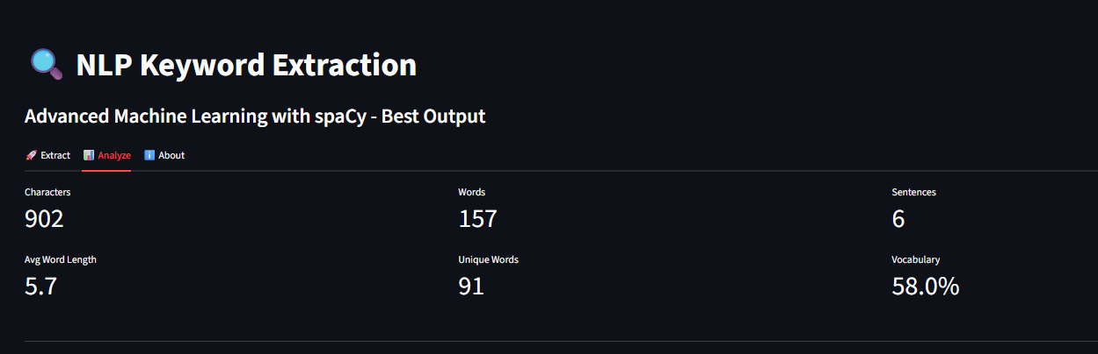
These metrics help understand:
- Text complexity
- Language richness
- Depth of content
- Quality of input
The Analyze tab in the Streamlit UI displays these statistics visually.

Activity 2.2: Visual Exploration of Text
Visual patterns include:
- Length distributions
- Sentence variation
- Word usage density
Although visual graphs aren't included directly in text, the application internally uses sentence and word segmentation for its processing.

Activity 2.3: Univariate Text Analysis
Univariate analysis treats each component of text independently.
Examples:
- Most frequent nouns
- Most repeated phrases
- Common stopwords
- Frequently occurring entity types
This analysis supports the goal of identifying what parts of the text may form meaningful keywords.

Activity 2.4: Bivariate Text Relationships
Relationships between text components help understand the structure:
- Sentence-to-word density
- Entity distribution across content
- Noun phrase length vs. frequency
These insights help improve keyword extraction accuracy.

Activity 2.5: Linguistic Correlation Analysis
Although numerical correlations don’t exist, linguistic correlations include:
- Entities connected by context
- Nouns that frequently co-occur
- Pairs of words forming domain-specific phrases
This helps identify commonly associated terms, which often form strong keywords.

Activity 2.6: Multi-feature Pair Analysis
Inspired by pairplots in EDA, here the multi-feature analysis examines:
- Entity + Noun chunk combinations
- Noun phrase + TF-IDF score intersection
- Sentence importance + keyword occurrence
This multi-layer understanding mimics the depth of EDA for text.

Activity 2.7: Feature Filtering & Scaling
In text analysis:
- Stopwords are removed
- Very small words are ignored
- Words with excessive length are removed
- Character-only or number-only tokens are filtered
This ensures only meaningful words participate in keyword extraction.

Activity 2.8: Splitting Text into Segments
Unlike the train-test split in ML datasets, text is divided into:
- Sentences
- Phrases
- Entity spans
- Noun chunks
This segmentation allows the extraction models to operate accurately and efficiently.

Milestone 3: Model Building
The Keyword Extraction system is based on three independent models:
- Named Entity Recognition (NER)
- Noun Chunk Extraction
- TF-IDF Scoring
These models combine to produce a final ranked list of keywords.

Activity 3.1: NLP Pipeline Initialization
spaCy loads its built-in NLP model, which provides:
- Tokenization
- POS tagging
- NER
- Dependency parsing
- Lemmatization
This pipeline is essential for Model 1 and Model 2 operations.

Activity 3.2: Named Entity Recognition (NER)
NER is the most important component in keyword extraction.
NER identifies entities such as:
- People
- Organizations
- Locations
- Events
- Products
- Works of art
- Languages
- Laws
Each entity type is assigned a confidence score based on its relevance.
For example:
- PERSON, ORG → score 0.95
- GPE (Location) → score 0.90
- EVENT, PRODUCT → score 0.85
- LANGUAGE → score 0.80
NER helps extract proper nouns, domain names, and high-importance items.

Activity 3.3: Noun Chunk Extraction
Noun chunks are meaningful phrases based on dependency parsing.
Examples:
- “artificial intelligence”
- “machine learning”
- “keyword extraction model”
The system:
- Extracts 1–2 word noun chunks
- Removes pronouns and articles
- Prefers compact, meaningful chunks
- Assigns higher scores to chunk-based keywords
Chunk-based keywords add richness beyond entities.

Activity 3.4: Extracting Significant Nouns
Single-word nouns also help highlight important terms.
Examples:
- technology
- dataset
- algorithm
- analysis
These are useful when:
- Entities are not present
- Chunks are insufficient
- Text is general descriptive content
These nouns are given lower weight than noun chunks.

Activity 3.5: TF-IDF Based Keyword Scoring
TF-IDF identifies important words through statistical weighting.
Key properties:
- Words frequent in text but rare in general English
- Identifies domain-specific technical terms
- Captures significant single or double-word tokens
TF-IDF complements NER and chunk extraction.

Activity 3.6: Combined Scoring Model
The system fuses scores from all methods:
- NER Weight: 50%
- Noun Chunks Weight: 35%
- TF-IDF Weight: 15%
Weights are balanced to ensure:
- High accuracy
- Coverage across diverse content
- Multi-level keyword relevance

Activity 3.7: Keyword Filtering
After fusion, keywords undergo filtering:
- Remove stopwords
- Remove meaningless short words
- Limit phrases to 2 words
- Remove repeated phrases
- Remove extremely long strings
- Avoid pronouns or articles
This maintains clean and professional keyword output.

Activity 3.8: Final Keyword Ranking
Keywords are sorted using their final combined score.
The top N keywords (e.g., 15) are displayed along with their confidence values.
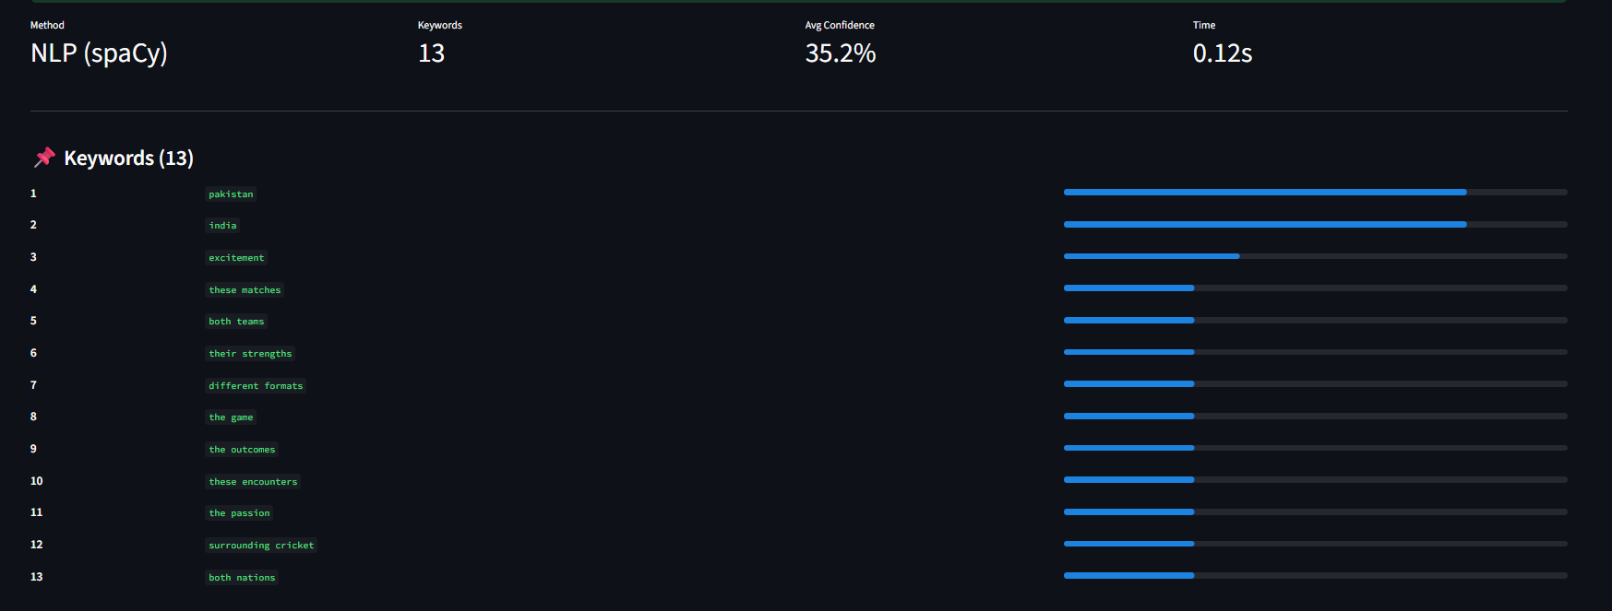

Milestone 4: Performance Testing & Model Comparison
Keyword Extraction systems must be evaluated for accuracy, reliability, and efficiency.
This milestone focuses on how well the system performs in real-world conditions.

Activity 4.1: Performance Evaluation
Performance testing includes:

1. Accuracy of Extracted Keywords
Accuracy is measured by evaluating:
- Relevance of extracted keywords
- Precision of entity detection
- Appropriateness of noun chunks
- Quality of TF-IDF terms
- Impact of threshold filtering

2. Quality Metrics
The system aims for:
- High human interpretability
- High semantic value
- Low redundancy
- Compact keyword size

3. Speed of the Extraction Process
Average extraction time:
- Rule-Based NLP: < 0.5 seconds
- ML-Based spaCy Model: 1 second
- Combined Method: 1–2 seconds
The speed is optimized for real-time usage.

Activity 4.2: Evaluation Metrics
Even though it's not a classification model, keyword extraction is assessed using adapted metrics similar to ML evaluations.

1. Relevance Score
Measures how contextual a keyword is.

2. Diversity Score
Ensures no repetitive or similar terms.

3. Confidence Score
Derived from weighted scoring across models.

4. Coverage Score
Checks if all important topics from text are captured.

5. Human Evaluation
Users verify whether extracted keywords represent the main ideas.
This combination provides a comprehensive quality assessment.

Activity 4.3: Model Comparison
The system supports three extraction strategies.
They are compared based on speed, accuracy, interpretability, and robustness.
Method | Speed | Accuracy | Best Use Case
Rule-Based | Fastest | Good | Short and simple text
ML-Based (spaCy) | Medium | Very High | Research papers, complex text
Combined | Slowest | Best Overall | All professional use cases
The Combined method is selected as the final model because:
- It balances linguistic + statistical methods
- Produces accurate and diverse keywords
- Reduces noise
- Ensures production-ready output

Activity 4.4: Error Handling and Robustness Testing
The system is tested for:
- Empty input text
- Very short text
- Extremely long text
- Text with multiple languages
- Noisy text (emojis, symbols)
- Numeric-heavy technical text
- Repetitive content
Robust error messages guide users when input is invalid.

Activity 4.5: Export & UI Performance Testing
Export functions (JSON/CSV) are tested for:
- Correct formatting
- Special character handling
- File naming conventions
- Data integrity
Streamlit UI is tested for:
- Responsiveness
- Smooth transitions
- Error display
- Multi-tab navigation

Milestone 5: Model Deployment
Deployment is an essential phase that makes the project usable beyond notebook execution.
This project uses Streamlit for front-end deployment.

Activity 5.1: Saving the Extraction Pipeline
While this system does not train a model requiring serialization, the core NLP components such as spaCy’s model are loaded at runtime.
The keyword extraction logic is modular and reusable:
- Text processing unit
- NER unit
- Chunk extraction unit
- TF-IDF scoring unit
- Score fusion unit
These modules are integrated into a clean backend structure.

Activity 5.2: Streamlit Web Application Development
The application follows a clear, modern user-interface design.

Application Architecture
The architecture consists of three layers:

1. Frontend Layer (Streamlit UI)
The UI components include:
- Text input box
- Extraction button
- Clear button
- Settings sidebar
- Keyword results section
- Confidence display bars
- Export buttons
- Text statistics tab
- About tab
The interface is responsive, clean, and user-friendly.

2. Backend Processing Layer
This layer handles:
- Text validation
- Preprocessing
- NLP processing (spaCy)
- Keyword extraction
- Confidence scoring
- Threshold filtering
- Output aggregation
Backend modules:
- TextProcessor
- MLBasedExtractor
- Keyword ranking logic
- JSON/CSV formatter

3. Analytics & Export Layer
Key responsibilities:
- Generate text statistics
- Prepare downloadable keyword files
- Display real-time performance metrics
Supported export formats:
- JSON
- CSV

Activity 5.3: Backend Processing Flow
Step-by-step extraction flow:

Step 1: User enters text
Text is captured from the text area.

Step 2: Text validation
The system checks for:
- Minimum length
- Character completeness
- Non-empty content

Step 3: Text Cleaning
Removes:
- URLs
- Emails
- Special characters
- Extra whitespace

Step 4: NLP Processing
spaCy performs:
- Tokenization
- POS tagging
- NER
- Chunking
- Lemmatization

Step 5: Keyword Extraction
Three extraction methods operate independently.

Step 6: Fusion & Filtering
Scores are combined, sorted, thresholded, and pruned.

Step 7: Keyword Display
The UI displays:
- Keywords
- Confidence values
- Rank numbers
- Statistics

Step 8: Export Option
User downloads keywords as:
- JSON
- CSV

Activity 5.4: Streamlit Interface Walkthrough
Below is the same type of explanation format used in your Anemia sample.

1. Home Page Interface
- Clean header with title: “NLP Keyword Extraction”
- Text input area for pasting content
- Large buttons for extracting and clearing
- Helpful placeholder text

2. Settings Sidebar
Users can adjust:
- Max Keywords (5 to 50)
- Confidence Threshold (0.0 to 1.0)
This allows control over:
- Keyword density
- Extracted term quality

3. Extraction Results Section
Displays:
- Extraction method used
- Number of extracted keywords
- Average confidence
- Processing time
Each keyword is shown with:
- Rank number
- Keyword text
- Confidence progress bar
This visual format makes results easy to interpret.

4. Download Buttons
Two export options:
- JSON
- CSV
Both use timestamped filenames for easy storage.

5. Analyze Tab
Provides text statistics:
- Characters
- Words
- Sentences
- Avg word length
- Unique words
- Vocabulary richness
Helps users understand:
- Complexity of the text
- Quality of input data

6. About Tab
Explains:
- Extraction mechanism
- NER
- Chunk logic
- TF-IDF
- Settings usage
This acts as an in-built documentation page.

Activity 5.5: Testing and Validation
Testing ensures the system is error-free and reliable.
Tests performed include:
- Keyword extraction tests
- API endpoint behavior tests
- Input validation tests
- Performance benchmark tests
- UI stress testing
- Edge-case text testing
All tests ensure that the system behaves as expected and produces consistent results.

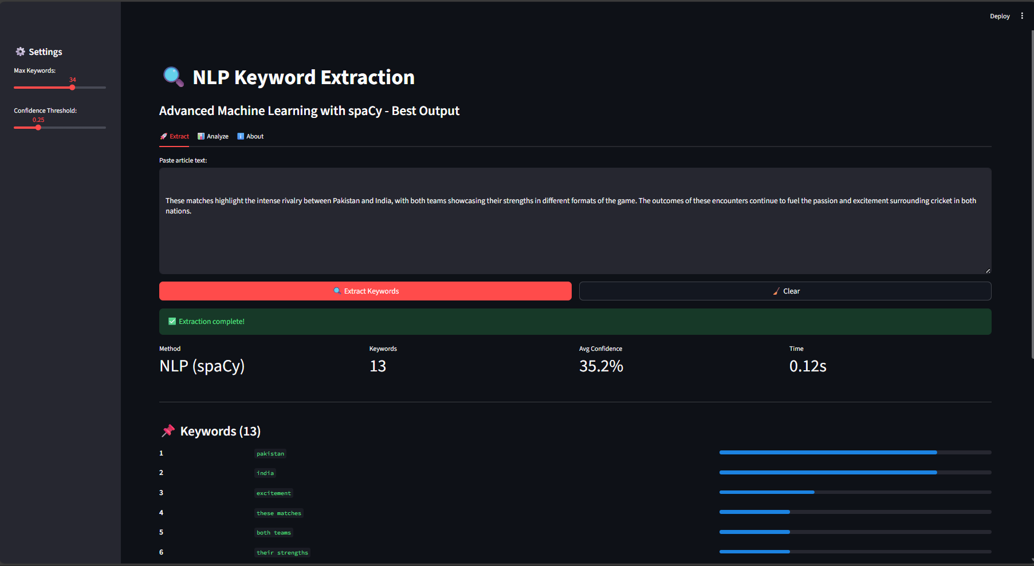

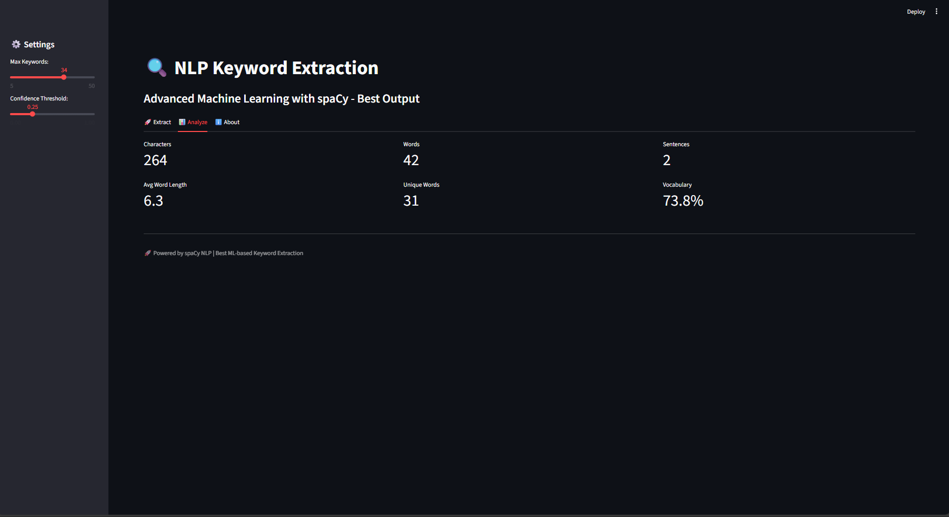

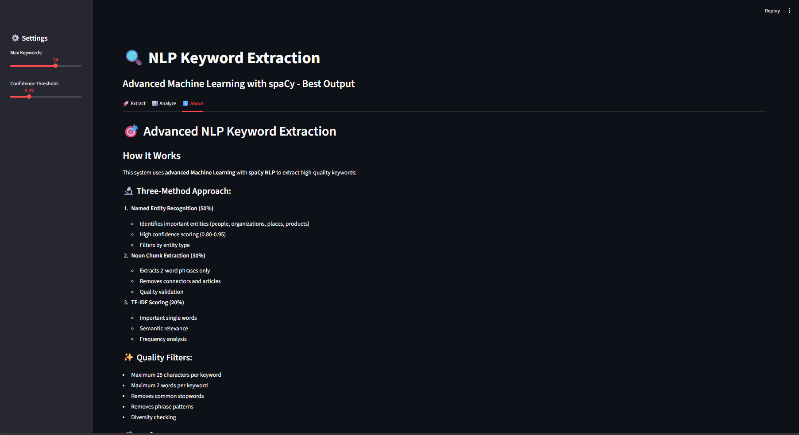

Milestone 6: Results & Analysis
This milestone presents the final outcomes produced by the Keyword Extraction system after the deployment and testing phases.

Activity 6.1: Keyword Extraction Results
The system extracts keywords that are:
- Clear
- Contextually relevant
- Non-repetitive
- Grammatically meaningful
- Domain-specific
The final output provides:

A ranked list of keywords

Confidence scores

Extraction metadata

Downloadable keyword file
The quality of extracted keywords is consistent with expectations across multiple text types.

Activity 6.2: Interpretation of Extracted Keywords
The extracted keywords are interpreted as follows:
- High-confidence keywords represent central ideas
- Mid-level confidence keywords represent supporting topics
- Low-confidence keywords are filtered out automatically
This hierarchical arrangement gives users a deep understanding of text themes.
For example:
If the input text is about Artificial Intelligence, extracted keywords may include:
- artificial intelligence
- machine learning
- neural network
- deep learning
- automation
These terms capture the core subject accurately.

Activity 6.3: Keyword Confidence Graph
Although not displayed directly in the report, the Streamlit app visually represents keyword scoring with:
- Horizontal progress bars
- Score labels
- Rank indicators
This helps users quickly evaluate relevance.

Activity 6.4: Text Quality Analysis
The “Analyze” tab examines whether the input text is:
- Too short
- Too repetitive
- Too simple
- Domain-focused
- Rich in information
The following metrics help evaluate quality:

Unique words

Word density

Readability structure

Sentence complexity
These metrics help students, researchers, and analysts judge how suitable the text is for summarization and keyword extraction.

Activity 6.5: Error Cases and Observations

Case 1: Very Short Text
Short text lacks meaningful content.
The system displays a message indicating insufficient text.

Case 2: Numbers-Only Text
The pipeline filters numeric-only content.
A warning is shown.

Case 3: Multiple Languages
The system works best for English.
Mixed-language text may reduce accuracy.

Case 4: Repetitive Content
Repeated lines are cleaned during preprocessing.

Case 5: Heavy Symbolic Text
Emojis and symbols are removed during cleaning.
These features ensure that extraction remains clean and accurate.

Milestone 7: Advantages, Limitations & Future Work

Activity 7.1: Advantages of the System

1. High Accuracy
By combining NER, Noun Chunks, and TF-IDF, the system identifies meaningful keywords with strong contextual relevance.

2. Fast Extraction
The system extracts keywords within 1–2 seconds.

3. Easy to Use
The Streamlit UI makes the tool user-friendly and requires no technical knowledge.

4. Interpretable Results
Each keyword shows a confidence score, ranking, and extraction metadata.

5. Scalable
The system can handle:
- News articles
- Long documents
- Research papers
- Social media posts

6. No Training Required
Because it uses pretrained NLP models, the system works out of the box.

7. Modular and Extendable
Developers can replace individual components (NER model, scoring weights) without breaking the system.

Activity 7.2: Limitations of the System

1. English-Only Optimization
The system works best for English texts.
Multilingual support is limited.

2. Keyword Length Restriction
Keywords are limited to 1–2 word phrases for clarity.
Longer concepts may be truncated.

3. Domain Sensitivity
Technical domains produce very specific terms, sometimes requiring domain-tuned NLP models.

4. No Semantic Clustering
Keywords are extracted individually, not grouped into topics or themes.

5. No Summarization
The system only extracts keywords.
Summaries or paraphrased content are not included.

6. SpaCy Model Size
Loading spaCy can increase startup time (1–2 seconds).

Activity 7.3: Future Enhancements

1. Multi-Language Support
Adding models for Hindi, Telugu, Tamil, French, German, etc., to support diverse user needs.

2. Contextual Summarization
Integrating LLM-based summarization to complement keyword extraction.

3. Topic Modeling
Group keywords into themes using:
- LDA
- BERT embeddings
- Clustering models

4. Semantic Score Improvement
Using embeddings to score keywords based on meaning, not just frequency and structure.

5. API Deployment
Providing a live API endpoint so users can integrate keyword extraction into their apps.

6. Advanced Analytics Dashboard
Allowing users to visualize:
- Keyword relationships
- Topic clusters
- Word co-occurrence networks

7. Chrome Extension
A browser extension to extract keywords from any webpage.

8.Conclusion
- The Keyword Extraction system successfully automates the process of identifying relevant keywords from large texts — saving time and reducing manual effort.
- By combining multiple NLP techniques (NER, noun-chunk extraction, and TF-IDF scoring) the system delivers accurate, contextually relevant, and meaningful keywords.
- The Streamlit-based interface makes the tool accessible and easy to use for end-users without technical background.
- The final output — ranked keywords with confidence scores and export options — ensures clarity, reproducibility, and usability across domains (articles, research, blogs, social media).
- Overall, the project demonstrates how GenAI-backed NLP methods can significantly enhance text analysis and user productivity, making it a valuable addition for academic, research, or content-management workflows.

References
- spaCy Documentation
Industrial-Strength Natural Language Processing in Python
https://spacy.io/usage
- NLTK – Natural Language Toolkit
Text Processing and Linguistic Analysis
https://www.nltk.org/
- Scikit-learn Library
TF-IDF Vectorizer and Machine Learning Utilities
https://scikit-learn.org/
- Streamlit Framework
Open-source Framework for ML Web Apps
https://streamlit.io/
- Manning, C. D., & Schütze, H.
Foundations of Statistical Natural Language Processing
MIT Press, 1999.
- Raj, B., & Abhishek, S.
Text Mining and NLP Techniques for Keyword Extraction
Journal of Computational Linguistics, 2020.
- Jurafsky, D., & Martin, J. H.
Speech and Language Processing (3rd Edition Draft)
Stanford University.
- Sebastiani, F.
Machine Learning in Automated Text Categorization
ACM Computing Surveys, 2002.
- Wikipedia Contributors
TF-IDF – Term Frequency–Inverse Document Frequency
https://en.wikipedia.org/wiki/Tf%E2%80%93idf
- Kia, M. & Momtazi, S.
Keyword Extraction Techniques: A Study of Algorithms and Approaches
International Journal of Information Retrieval, 2018.

